**Set Operators in Oracle : UNION , UNION ALL, INTERSECT , MINUS**

**Union** : The UNION operator is a set operator that combines result sets of two or more [SELECT](https://www.oracletutorial.com/oracle-basics/oracle-select/) statements into a single result set.

FIELDS order SHOULD BE SAME

DATA TYPE SHOULD BE SAME

LENGTH SHOULD BE SAME.

## **Oracle UNION illustration**

Suppose, we have two tables T1 and T2:

* T1 has three rows 1, 2 and 3
* T2 also has three rows 2, 3 and 4

The following picture illustrates the UNION of T1 and T2 tables:

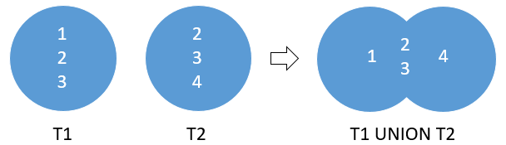

**The UNION removed the duplicate rows 2 and 3**

**Union All :**

The following picture illustrates the result of the UNION ALL of the T1 and T2 tables:

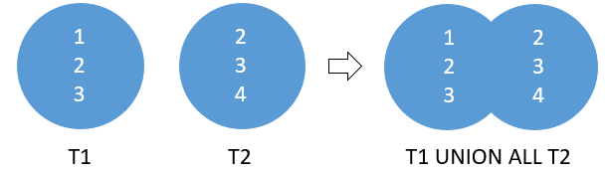

**As you can see, the UNION ALL retains the duplicate rows 2 and 3.**

**Oracle UNION Example :**

SELECT first_name, last_name,email,'contact' FROM contacts

UNION

SELECT first_name, last_name,email,'employee' FROM employees;

SELECT first_name || ' ' || last_name name,email, 'contact' FROM contacts

UNION

SELECT first_name || ' ' || last_name name, email,'employee' FROM employees

ORDER BY name DESC;

### **Oracle UNION ALL example**

UNION :

SELECT last_name FROM employees

UNION

SELECT last_name FROM contacts

ORDER BY last_name; -- 357 unique records

SELECT last_name FROM employees

**UNION ALL**

SELECT last_name FROM contacts

ORDER BY last_name; -- 426 records WITH DUPLICATES

**INTERSECT**  : The Oracle INTERSECT operator compares the result of two [queries](https://www.oracletutorial.com/oracle-basics/oracle-select/) and returns the [distinct](https://www.oracletutorial.com/oracle-basics/oracle-select-distinct/) rows that are output by both queries.

**The following picture illustrates the intersection of T1 and T2:**

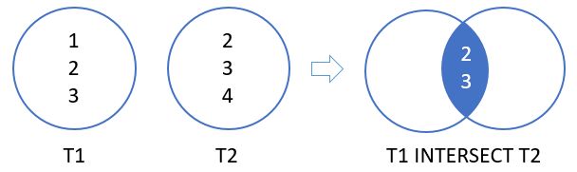

Example :

SELECT last_name FROM employees - 10

INTERSECT

SELECT last_name FROM contacts -10

ORDER BY last_name; --29 RECORDS

1 field

2 records

Emp -10

Dept -10

Select a.empid,a.ename,a.deptno, b.deptno, b.deptid,b.dname from emp a dept b where a.deptno=b.deptno

6 fields

10 records

**MINUS :**

MINUS operator is used to return all rows in the first SELECT statement that are not in the second SELECT statement.

The MINUS operator is used to subtract the result set obtained by first SELECT query from the result set obtained by second SELECT query.

The MINUS operator returns rows in the first query that are not present in the second query.

The following picture illustrates the result of the MINUS of T1 and T2:

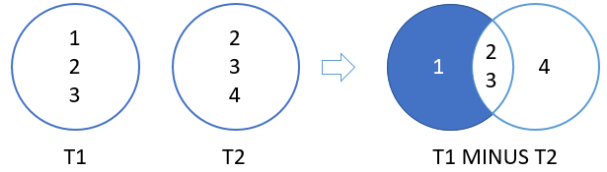

**Here are the last names returned by the first query but are not found in the result set of the second query:**

**Example :**

SELECT last_name FROM employees

minus

SELECT last_name FROM contacts

ORDER BY last_name;

**The following statement returns a list of product id from the products table, but do not exist in the inventories table:**

SELECT product_id FROM products

MINUS

SELECT product_id FROM inventories;